Media Highlights
May 2024

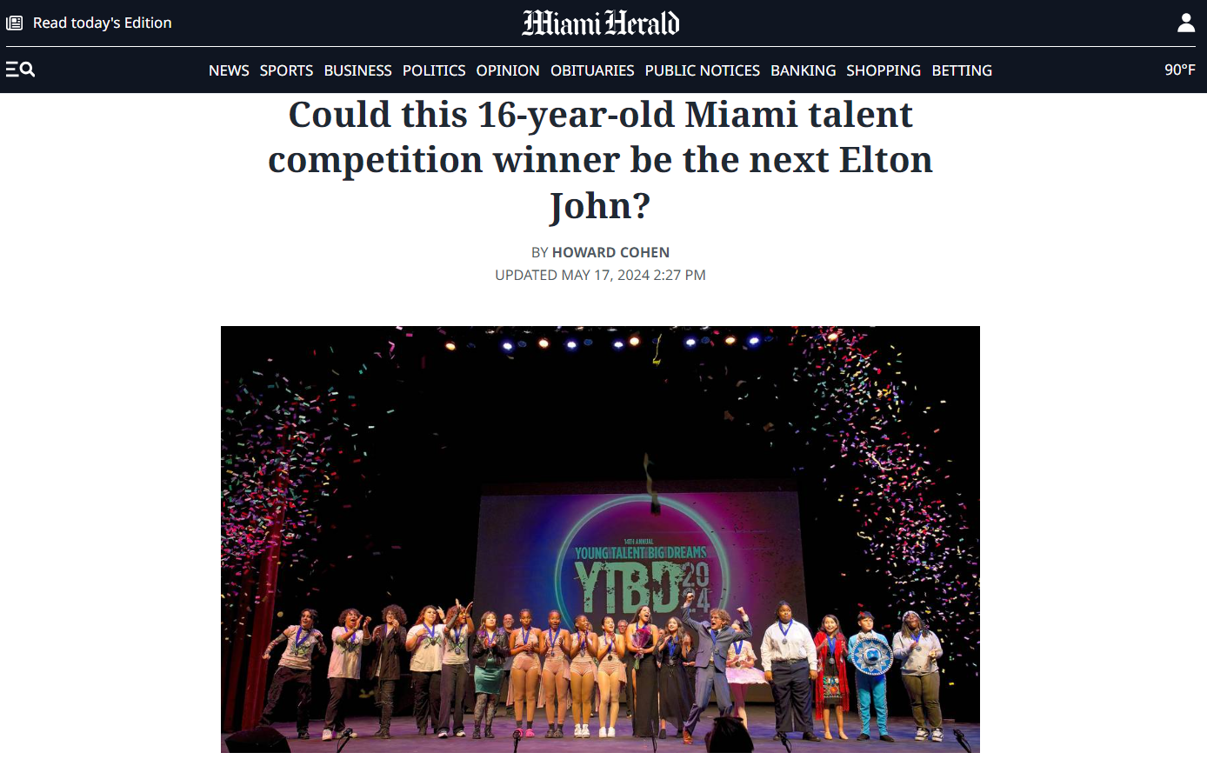

How do you deem a teen’s exciting instrumental composition the best of the best over an exquisite harmony vocal performance? Or over a timely spoken word performance of female empowerment that could give “Barbie” script writers a run for the Oscar? Or over an achingly detailed solo cello performance or a rock band of high schoolers covering a rousing ‘80s hit that bested Bon Jovi’s original?
You do so with years of experience observing the arts — and sometimes with some lively judges’ dressing room debate among seasoned Miami-area professionals.
Actors’ Playhouse at the Miracle Theatre, together with presenting sponsor The Children’s Trust, announced the 2024 winners of the 14th annual Young Talent Big Dreams, a local, free youth talent competition that has spread its search across Miami-Dade County every year since 2010.
For Young Talent Big Dreams, students, ages 8 to 18, living in Miami-Dade, are invited to compete in nine categories that tap their talents. The competition features six individual categories: pop/rock/rap vocals, musical theater/jazz standards/classical vocals, dance, musical instrument, original spoken word, and original vocal and/or instrumental composition. There are also three group categories for dance, musical instrument/bands, and vocal groups.
A three-month marathon of preliminary and semifinal competitions at the Miracle Theatre in Coral Gables, the Dennis C. Moss Cultural Arts Center in Cutler Bay and Sandrell Rivers Theater in Liberty City that drew hundreds of contestants culminated in the finals at the Miracle on Saturday, May 11. Prizes include cash awards, master classes with industry professionals, performance opportunities and performing arts scholarships.
The finals competition, after a series of audition rounds that began in March, was held on the Actors’ Playhouse stage at The Miracle Theatre.
As a volunteer judge for Young Talent Big Dreams since the “Star Search”-styled competition’s inception 14 years ago, it would sound like a disservice to previous winners who have gone on to perform at community events and who have pursued their artistic fields nationally, to call the 2024 finalists the best of the bunch.
So I’ll just say that while watching the evening’s grand prize winner pounding the piano with a rousing tune he wrote — while doing almost everything to that piano to entertain an audience except playing it upside down — I was reminded of a historic moment in pop music history.
In May 1970, Robert Hilburn, the influential pop music critic for the Los Angeles Times, wrote a review that British pianist-songwriter Elton John, now 77, credits with giving him his break in the United States. Hilburn’s opening paragraph in that now legendary review began: “Rejoice. Rock music, which has been going through a rather uneventful period lately, has a new star. He’s Elton John, a 23-year-old Englishman whose United States debut Tuesday night at the Troubadour was, in almost every way, magnificent.”
As Gerry Ibarra, a 16-year-old from Terra Environmental Research Institute in the Kendall area, delivered his exhilarating piano performance of his original piece entitled, “Rat Race,” I flashed back to the fancifully staged scene in the Elton John biopic movie, “Rocketman.” That image showed the future superstar levitating at his piano at the L.A. music club as Hilburn’s review flashed across the screen.
This kid was good. Better than good. We were seeing some of the best of the best young talent Miami has to offer. After the obligatory judges’ stage pose with the winners, I leaned over toward Gerry and whispered, “You ever hear of Elton John?”
The young musician and composer didn’t break his smile or waves to the audience of family, educators and arts-enthusiasts. Gerry has heard of the older star. He liked the compliment.

Gerry was crowned the Original Composition Winner and the Overall Grand Prize Champion by four judges: David Arisco, artistic director, Actors’ Playhouse at the Miracle Theatre; Shamele Jenkins, artistic director of Lip, Tongue & Ear Poetry Productions and executive director/immediate past president of the Miami-Dade County Foster & Adoptive Parent Association; Ruby Romero-Issaev, executive director/CEO of Arts Ballet Theatre of Florida; and yours truly, a 33-year veteran Miami Herald reporter with a background in pop music and theater criticism.
Gerry received $500 cash provided by Actors’ Playhouse, and four tickets to Universal Orlando along with a hotel stay for two nights courtesy of WSVN-7News.
“Actors’ Playhouse is immensely proud of the role that we have played in nurturing young performers for over 35 years, including the past 14 years through the Young Talent Big Dreams competition,” said Barbara Stein, executive producing director of Actors’ Playhouse at the Miracle Theatre. “It is exhilarating to watch these young talents shine.”
Adds James Haj, president and CEO of co-presenter, The Children’s Trust: “We believe in investing in developing skills and talent in Miami-Dade County’s youth, and Young Talent Big Dreams is one way we do so. Through various partnerships across the community, we are able to provide more opportunities for children to engage in the arts and create a community where creativity thrives.”

The 2024 YTBD winners
Here are the judges’ selections of the best of the best. The 2024 Young Talent Big Dreams contest winners:

▪ Original Composition and Overall Grand Prize: Gerry Ibarra, 16, Terra Environmental Research Institute.

▪ Individual Dance: Maribelle Juvier, 12, Miami Arts Studio 6-12 @ Zelda Glazer.

▪ Individual Vocal – Broadway/Jazz/Classical: Stephanie Aguiar, 16, Somerset Preparatory Academy.

▪ Individual Vocal – Pop/Rock/Rap: Luna Meneses, 17, Doral Academy Preparatory High School.

▪ Individual Original Spoken Word: Salandra Singleton, 17, Miami Norland Senior High School.

▪ Individual Musical Instrument: Harmoni Warren, 16, Arthur & Polly Mays Conservatory of the Arts.

▪ Group Vocals: Mariachi featuring Dylan Bustos, 13, and Shantel Ruiz, 12, of Miami Arts Studio 6-12 @ Zelda Glazer.

▪ Group Dance: The Quadratic Four featuring Tylah Dorsonne, 14; Shannon Millan, 13; Ariannah Wright, 15; and Azariah Wright, 13; students at Arthur & Polly Mays Conservatory of the Arts.

▪ Group Musical Instrument/Bands: The Atomic Lollipops featuring Atlas Alvarez, 18, Miami Southridge Senior High School; Nya Fabian, 16, Homestead Senior High School; Ray Garcia, 16, South Dade Senior High School; Natalia Gomez-Mieses, 16, Homestead Senior High School; Kevin Perez, 18, Homestead Senior High School; and Liz Ponce, 17, Dade Preparatory Academy.

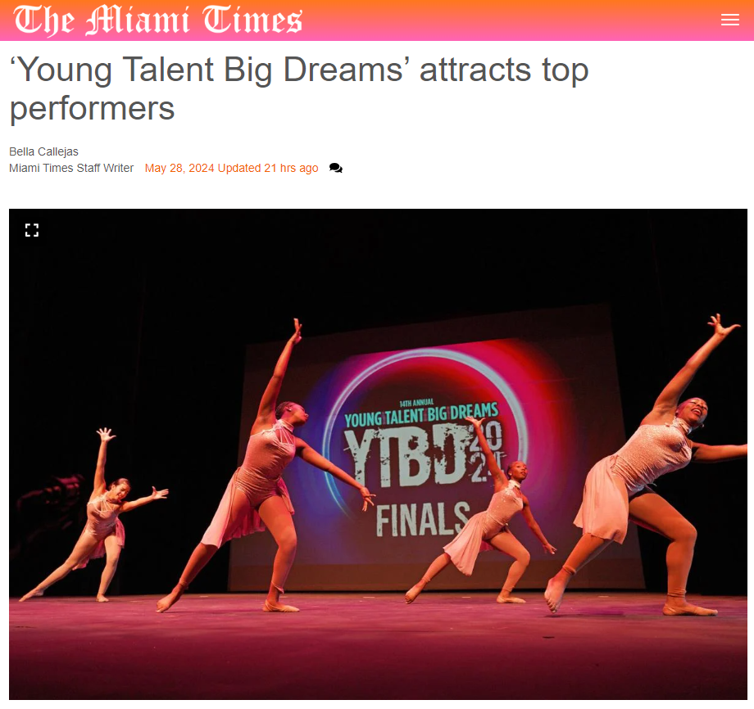
Actors’ Playhouse at the Miracle Theatre, in partnership with The Children’s Trust, recently announced the winners of this year’s 2024 Young Talent Big Dreams (YTBD) competition. Now in its 14th year, the event has cemented itself as a lifeline for young artists seeking to showcase their abilities and receive professional feedback.
This year’s countywide talent competition drew more than 300 participants – ranging in age from 8 to 18 – over a period of weeks.
“A wonderful thing that I noticed this year is we had so many alumni returning, some competing in different categories or continuing to participate because they enjoyed it so much,” said Earl Maulding, Actors’ Playhouse director of theatre for young audiences, who leads YTBD. “The competition matured, meaning that the performers took a chance on themselves, and the judges provided feedback to help them grow. This growth opportunity was a supportive environment where young performers could quickly develop their skills.”
One of the most enticing aspects of the competition is its range of categories, which include pop/rock/rap vocals, musical theater/jazz standards/classical vocals, dance, musical instrument, original spoken word, and original vocal and/or instrumental composition. Additionally, there were three group categories for dance, musical instruments/bands and vocal groups. This variety allows a broad spectrum of talent to shine.
Maulding explained that even though not every performer walked out a winner, Actors’ Playhouse provided experiences and mentorship for all the competition’s participants.
“We called the finalists to set up performance opportunities where they had to go somewhere they had never been before, for people they didn’t know,” said Maulding. “And they had to walk in as young professionals and take the stage no matter what the situation.”
Salandra Singleton, a 17-year-old student at Miami Norland Senior High School and a member of the Viking Freedom Writers, won for Individual Original Spoken Word. Singleton captivated audiences with a performance of her deeply personal original poem, “Cause I’m A Woman.”
She shared that she explored in her piece “Things that women experience on a day-to-day basis, like not being valued in their relationship or being scrutinized because their clothes are too tight. It’s basically saying, even though I do this, or be this, or do what I’m told to, I can never get it right because I’m simply a woman.”
Singleton prepared for the competition by practicing in front of a mirror to build her confidence. Despite her stage fright, she managed to channel her emotions and deliver a powerful performance. Winning the competition left her feeling shocked and proud, as it validated her talent and hard work. She’s now motivated to pursue future opportunities in spoken word and to work toward becoming a published author.
Maulding praised Singleton’s ability to take her personal experiences and express them powerfully on stage, noting, “The fact that she was willing to stand on stage by herself and share her experiences in a strong, commanding, yet personal way set an unbelievable example.”
Harmoni Warren, the 16-year-old winner of the Individual Musical Instrument category, is a multi-instrumentalist known for her proficiency in cello. While she preferers that instrument, she has played tuba and trumpet in various school bands, expanding her musical repertoire. Performances with esteemed ensembles like the K.U.M.C. Orchestra and Nu Deco N.X.T. Youth Ensemble have showcased her versatility and dedication to music.
Maulding expressed high expectations for her future.
“I expect to see that girl playing with the finest symphony orchestras anywhere in the world someday,” he said of Warren. “Her touch and connection with her instrument were extraordinary.”
Warren performed for the first time in the competition this year; to prepare she practiced extensively, focusing on the demanding cello piece she would perform at YTBD. Despite feeling anxious and scared backstage before she went on, she said once she was on stage she felt confident and at ease.
“It was a lot for me anxiety-wise. I was scared, but once I was on stage, I was good. It was smooth sailing from there,” she said.
Warren’s favorite part of the competition was watching all the other performances after she finished her own; she said she found it inspiring to witness the diverse talents of other young musicians. As for her future aspirations, she expressed a desire to become a music educator.
“I’ve been inspired by music teachers that I’ve had to be better not only in my musicianship, but in life in general,” she said. “I want to be that person for someone, that second home for someone the way that these teachers here at my school have been for me.”
Another act that received high praise was The Quadratic Four, winners of the Group Dance category. Its members – Tylah Dorsonne, 14, Ariannah Wright, 15, Azariah Wright, 13, and Shannon Millan, 13 – attend the Arthur & Polly Mays Conservatory of the Arts.
Formed during a student choreography month in their dance class, Quadratic Four chose Whitney Houston’s “I Will Always Love You” as the centerpiece of their performance. What began as a choreography project soon blossomed into a bonding experience for the group.
Dorsonne emphasized the importance of chemistry among the group members, attributing much of their performance’s impact to their shared love of dance. Their choreography, fueled by their creative imagination, is a testament to their passion and dedication.
“When we heard a song, we automatically knew that we wanted to make a piece to it. And all of a sudden, we came up with choreography, and it just all came together,” she said.
At the competition, she and her fellow dancers impressed judges with their classical technique and strong unified performance. Indeed, Maulding highlighted their commitment to technique and style, saying, “They were classically trained, projecting their energy in a very classical style of dance. Their strong unison dancing made them stand out as a cohesive unit rather than individuals.”
Reflecting on their journey, Dorsonne acknowledged areas for improvement but remained excited about future competition opportunities. Her advice to aspiring artists was simple yet powerful: “Give your best and embrace the experience fully.”

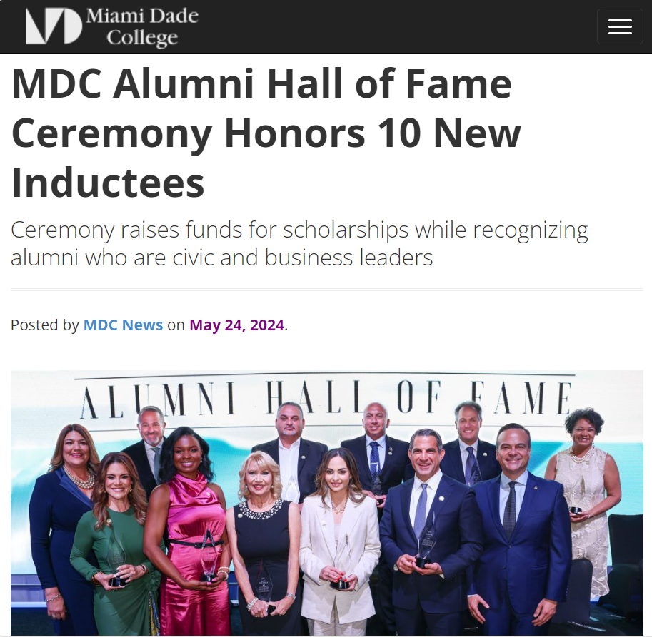
Miami Dade College recently honored a new class of outstanding community leaders at its 22nd MDC Alumni Hall of Fame Awards Ceremony held at the Loews Coral Gables Hotel.

The annual Hall of Fame ceremony recognizes alumni who are civic and business leaders in the community and across the nation while raising vital funds to support student scholarships. Since 2003, more than 410 alumni have been inducted, representing various industries, from banking, journalism, marketing, public service, education, public safety and non-profit to name a few. MDC’s Hall of Fame is the signature fundraising event of the Miami Dade College Foundation.
Watch a short video of the festivities from MDC’s social media account.
“It is my privilege to honor a new group of exemplary leaders who join over two million MDC alumni making an impact in the community,” said MDC President Madeline Pumariega. “We are proud of their professional and personal accomplishments, and we thank them for their support and paving the way for future MDC students and alumni.”
Meet the 2024 MDC Alumni Hall of Fame inductees:
Banking
Vania Laguerre
Sr. Vice President, Local Market Executive
Bank of America
Laguerre’s illustrious career at Bank of America embodies the essence of leadership, community engagement, and unwavering dedication to fostering economic mobility. Her tenure at Bank of America spans three decades and showcases a remarkable evolution from roles in compliance, risk, business management and leadership to her pivotal position as the Local Market Executive. She orchestrates the firm’s strategic vision and philanthropic efforts in Miami, championing the cause of economic empowerment along with optimizing the delivery of Bank of America’s integrated resources to address financial needs. Her leadership extends beyond professional boundaries, embracing a passionate commitment to mentorship and diversity.

Business
Jesus Lebeña
Sr. Vice President, Corporate Operations
MasTec Communication Group
Lebeña exemplifies a remarkable career in global business and operations management. With over 25 years of experience, his expertise spans across supply chain, strategic sourcing, fleet operations, safety, business process improvement and mergers & acquisitions. At MasTec Communications Group, Lebeña oversees a broad spectrum of operations, including supply chain, facilities, fleet operations, safety & training and vendor management. His career milestones include pivotal roles at Motorola Corporation, where he contributed significantly to supply chain and operations and was ranked among the top 10% Outstanding Performers. He served as the Past President of the Kiwanis Club of Little Havana, where he participated in organizing Carnaval Miami, the largest Hispanic festival in the United States.

Education
Mari Tere Rojas
School Board Chair, District 6
Miami-Dade County Public Schools
Rojas, Chair of the Miami-Dade County School Board, the third-largest A-rated School District in the nation, has shown commitment to education and community growth by taking proactive steps to solve pressing issues, including academic excellence, school safety, mental health and addressing the teacher shortage. Most recently, the Prime Minister of France named her Officer of the Order of Academic Palms, the highest honor granted to academics and cultural education figures. She was also featured the book “Cuban American Women Making History.” Numerous awards include Elected Leader, Fiscal Management, National Distinguished Principal and Region IV Principal of the Year, The National Blue Ribbon School of Excellence, Governor’s Sterling, Magnet Schools of America National Merit, and The Albert Nelson Marquis Lifetime Achievement.

Pharmacy
Stephanie Ann Perez
Central Pharmacy Pharmacist
Publix Supermarkets, Inc.
As a pharmacist for Publix Supermarkets, Inc., Perez significantly contributes to healthcare and patient well-being. Her professional journey is marked by her expertise, empathy and commitment, which are evident in her various roles within the field. Prior to Publix, Perez specialized as a Fertility Pharmacist, a position that honed her skills in patient care and empathy. This experience was integral in shaping her approach to pharmaceutical practice, focusing on patient-centered care and therapy management. Her proudest accomplishment is the successful balance of her professional responsibilities as a pharmacist and her personal life as a wife and mother of three. Her ability to manage these roles effectively highlights her dedication and commitment to both her family and her profession.

Journalism – Print
Alex Mena
Executive Editor
Miami Herald
Alex Mena’s illustrious career in journalism, marked by his rise to the position of Executive Editor at The Miami Herald and El Nuevo Herald, embodies a story of relentless dedication and professional excellence. He began his career in the media industry as a clerk at The Miami Herald, where he later held various key roles, including Managing Editor and Deputy Managing Editor before his current position as Executive Editor. Over the years, Mena’s career trajectory has been nothing short of remarkable. In addition to overseeing both daily papers, he serves as the McClatchy Florida Regional Editor, overseeing the Bradenton Herald. His responsibilities include steering the editorial direction, managing newsroom operations and ensuring journalistic excellence across multiple platforms.

Marketing
Heide Dans
Vice President
WOW MARKETING
Heidi Dans has significantly impacted her hometown of Miami through dedicated philanthropy and leadership. Alongside her husband, Jose “Pepe” Dans, she established WOW MKTG in 2005, an agency that excels in marketing and advertising, and also champions community engagement and support. Her extensive volunteer work includes organizations such as Miami Children’s Museum, Nicklaus Children’s Hospital and the American Cancer Society. Leadership roles, including mission chair of the American Cancer Society Gala, chair of the Miami Children’s Museum and co-chair of the Nicklaus Children’s Hospital Diamond Ball, highlight her ability to mobilize resources and awareness for crucial causes. She continues to serve as gala chair for the Chapman Partnership for the Homeless, marking her third term in this pivotal position.

José “Pepe” Dans
President
WOW MARKETING
José “Pepe” Dans is a paragon of entrepreneurial spirit and cultural advocacy in marketing. His early exposure to the media world began with selling ads in high school. His career exemplifies his foresight and adaptability in a rapidly evolving industry, marked by a progressive climb through various renowned media outlets. Dans demonstrated a unique understanding of market needs and audience engagement from his impactful sales tenure in television at WAMI-Channel 69 and WFLX to his strategic leadership at Univision Network. In 2005, he channeled this expertise into founding WOW Factor, which transformed into WOW MKTG, a full-service agency dedicated to amplifying the voice of the Hispanic market and beyond. Under Dans’ stewardship, WOW MKTG has expanded from a modest startup to a thriving multi-million-dollar enterprise.

Non-Profit
James R. Haj
President and CEO
The Children’s Trust
Haj has significantly improved the lives of children and families in Miami-Dade. Under his leadership, The Children’s Trust has seen unprecedented growth, expanding its reach and impact across the county. His tenure at Southwest Miami High School, his alma mater, was marked by his ability to drive positive change, leading the school from a ‘D’ to an ‘A’ grade, a testament to his transformative leadership. This success was a precursor to his significant roles in the Miami-Dade County Public Schools system, where he served as Assistant Superintendent of Labor Relations and Compensation and Administrative Director for both South and Central Region Offices. His time at MDC was a pivotal period that shaped his path as an educator and advocate for children.

Public Safety- Fire
Chief Raied S. Jadallah
Miami-Dade Fire Rescue
With a distinguished career in the fire service spanning over 28 years, Jadallah has been a cornerstone of Miami-Dade Fire Rescue. As the Fire Chief, he leads nearly 3,000 employees, oversees various critical aspects of fire rescue operations and coordinates with county leaders and government agencies to enhance public safety goals. He began his career with Miami-Dade Fire Rescue, advancing through the ranks from firefighter to Deputy Fire Chief. As an adjunct professor at Florida International University, he co-developed the Incident Command System Simulator Program, which integrates design factors and adult learning principles. His involvement in major incidents such as the Surfside Champlain Tower South Collapse and COVID-19 response showcase his leadership in critical situations, and earned him numerous awards and commendations, reflecting his exceptional service and dedication.

Public Service
Ashley V. Gantt
State Representative, District 109
Florida House of Representative
Gantt’s journey from inspired educator to the founder of Gantt Legacy Law, P.A. (GLL), exemplifies her dedication to service. She joined Teach for America and taught at Miami-Dade County Public Schools, where she shaped the minds of middle and high school students. She later transitioned into law to champion the rights of the underserved. As a Broward County Assistant Public Defender, her prowess in the courtroom was recognized with consecutive “Hat Trick” awards, highlighting her exceptional trial skills. Gantt’s leadership within the T.J. Reddick Bar Association, a fellow with the Florida Bar Wm. Reece Smith Jr. Leadership Academy, and the Gwen S. Cherry Black Women Lawyers Association illustrates her dedication to mentoring and elevating others in the profession.

About the Miami Dade College Foundation
Founded in 1965, Miami Dade College Foundation raises essential private funds to support scholarships, academic programs, and support services so MDC students have the opportunity to pursue their dreams. MDC Foundation also supports world-class arts and cultural programming at MDC that enriches the community. In 2022-2023, MDC Foundation distributed $26.8 million to benefit the students and programs of MDC. Known as Democracy’s College, MDC changes lives through accessible, high-quality teaching and learning experiences that prepare students for tomorrow’s workforce. Miami Dade College is the largest degree-granting institution in the nation. The college’s eight campuses offer more than 300 distinct degree pathways, including several baccalaureate degrees in biological sciences, engineering, data analytics, information systems technology, education, public safety, supervision and management, nursing, physician assistant studies, film, and others. For more information about the MDC Alumni Hall of Fame, please visit www.mdc.edu/halloffame.

